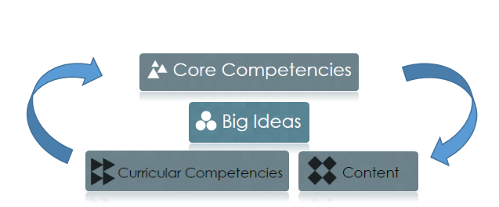

**Subject/Grade/Topic**

**First Peoples Learning Principles**:

**Guiding Question(s)**

**I can statements (Learning Targets)**

**Content**

**Curricular Competencies**

**Big Idea(s**

**Core Competency/Competencies**